Sleep Monitoring System

Abstract— Sleep is a crucial aspect of overall health and well-being, and many people struggle to get enough high-quality sleep. To help individuals improve their sleep quality, we propose a sleep monitoring system that uses a smartwatch and machine learning algorithms. This system collects data on sleep duration, sleep quality, heart rate, and other physiological factors, which are analyzed using machine learning algorithms to provide personalized insights and recommendations for improving sleep. These recommendations could include adjustments to sleep schedules, changes to sleep hygiene practices, or dietary changes that can improve sleep. By providing personalized recommendations tailored to each individual's unique sleep patterns and physiological factors, this system has the potential to be a powerful tool for improving sleep quality and overall health. With the increasing popularity of wearable technology and the growing demand for personalized health solutions, a sleep monitoring system that uses a smartwatch and machine learning algorithms could be a valuable tool for individuals looking to improve their sleep quality and overall well-being.
Keywords— User, system, Data, Sleep, Sensor, microcontroller, physical movement, stress, nap

Introduction
Our daily routines cannot be complete without sleep, and having enough good sleep is key to maintaining our general health and wellbeing. Obesity, diabetes, cardiovascular disease, and depression are just a few of the health problems that are linked to poor sleep quality. Unfortunately, many people struggle to get enough quality sleep, and in recent years, this problem has become more prevalent due to increased use of technology, work-related stress, and other factors.
To help individuals improve their sleep quality, we propose a sleep monitoring system that utilizes a smartwatch and machine learning algorithms. This system collects data on sleep duration, sleep quality, heart rate, and other physiological factors, which are analyzed by machine learning algorithms to identify patterns and correlations between different factors and sleep quality.
The proposed sleep monitoring system is designed to be user-friendly and non-intrusive. Users simply wear the smartwatch while sleeping, and the system collects data on their sleep patterns throughout the night. The collected data is then analyzed by machine learning algorithms to provide personalized insights and recommendations for improving sleep quality.
The system can provide recommendations based on several factors, including adjustments to sleep schedules, changes to sleep hygiene practices, or dietary changes that can improve sleep. For example, the system might recommend adjusting the user's bedtime or wake-up time based on their sleep patterns. It could also suggest implementing a consistent bedtime routine, such as avoiding electronic devices before bed or practicing relaxation techniques. The system could additionally recommend changes in diet that can enhance sleep quality, including avoiding coffee and alcohol before bed or eating more foods high in magnesium and tryptophan. The proposed sleep monitoring system has several potential benefits. First, it provides personalized recommendations tailored to each individual's unique sleep patterns and physiological factors. This is particularly important since sleep quality is affected by various factors, including age, gender, and medical history. By providing personalized recommendations, the system can be more effective in improving sleep quality compared to general sleep recommendations.
Second, The system is user-friendly and non-intrusive. Users can simply wear the smartwatch while sleeping, and the system does not require any active participation from the user. This ease of use can increase compliance and adoption rates.
Third, the system utilizes machine learning algorithms to analyze sleep data and provide personalized recommendations. This allows the system to identify complex patterns and correlations between different factors and sleep quality that may be difficult for humans to recognize. Additionally, the system can learn and improve over time as it collects more data, increasing its effectiveness in providing personalized recommendations.
An effective tool for people wishing to enhance their sleep quality and general wellbeing is a sleep monitoring system that makes use of a smartwatch and machine learning algorithms. The suggested sleep monitoring system can help people attain better sleep quality and enhance their general health and well-being in light of the rising prevalence of sleep-related problems and the growing need for personalized health solutions.

Problem definition
A serious health problem that a sizable portion of the population faces is inadequate sleep. Obesity, diabetes, hypertension, melancholy, and anxiety are just a few of the physical and mental health issues that can result from getting too little sleep. Many people find it difficult to comprehend their sleep patterns and implement significant changes to enhance their sleep. People can track their sleep and receive individualized recommendations for improvement with the use of a sleep monitoring system that uses a smartwatch and machine learning.
The answer is to create a sleep monitoring system that employs a smartwatch to gather information about a user's sleep patterns and machine learning algorithms to analyze the information and offer individualized insights and suggestions. The system will monitor a number of sleep metrics, including REM sleep, sleep length, and quality, and utilize this information to produce a sleep score. Once the sleep score has been analyzed, the system will give users information about their sleeping habits, including when they are most likely to wake up, how often they wake up during the night, and how much deep and REM sleep they are obtaining. The system would offer the user personalized suggestions for enhancing their sleep based on this data, such as altering their sleep routine, boosting.

Objective

To aid the user learn more about their own sleep patterns in order to enhance daytime efficiency, improve sleep quality, or address sleep issues including sleep disorders.

To reduce the chances of Insomnia and to have a proper sleep.

To develop a mobile application to help sleeping disorder patients, insomnia patients by keeping track of their sleeping cycles and seek for emergency help with ease.

Here, after developing mobile application, we keep all the records of data in this application and help the patients to overcome from this problem.

To upgrade the monitoring system, it will detect the time of sleeping, posture of sleeping and our sleep quality.

This system is mainly applicable for the people who are suffering from stroke, heart disease, and so on which will impact their quality of sleep.

The system will monitor the sleeping activity of a person and will provide the feedback based on data analyzed by the mobile application using machine learning that will help person in improving quality of sleep.

methodology
When a person is sleeping, their hand is connected to a wearable smartwatch called a Sleep Monitoring Device. Our body temperature and blood pressure drop as we sleep as the physiological demands are reduced. The majority of our physiological functions, such as heart rate, breathing, and brain wave activity, are very predictable during non-REM sleep but fairly changeable when we are awake or during REM sleep. Periodically throughout the night, REM sleep occurs, which is characterized by rapid eye movement, increased bodily activity while dreaming, a faster heartbeat, and shallower breathing. Non-REM sleep is a relaxed state of sleep characterized by low levels of autonomic physiological activity, delta wave brain activity, and dreaming. It always happens during a typical sleep cycle.
Physiological Process | NREM | REM
Neural activity | decreases from being awake. | augmentations in the motor and sensory regions, while other regions resemble NREM
Heart beat | Slows from wakefulness | Increases and varies compared to NREM
Arterial pressure | Decreases from wakefulness | Increases (up to 30 percent) and varies from NREM
Sympathetic nerve activity | Decreases from wakefulness | Increases significantly from wakefulness
Muscle tone | Similar to wakefulness | Absent
Blood flow to brain | Decreases from wakefulness | Increases from NREM, depending on brain region
Respiration | Decreases from wakefulness | Increases and varies from NREM, but may show brief stoppages; coughing suppressed
Airway resistance | Increases from wakefulness | Increases and varies from wakefulness
Body temperature | Is regulated at lower set point than wakefulness; shivering initiated at lower temperature than during wakefulness | Is not regulated; no shivering or sweating; temperature drifts toward that of the local environment
Sexual arousal | Occurs infrequently | Greater than NREM
So with the help of sleep monitoring device, we are going to measure different aspect of REM sleep.

Hardware and software used
Sleep monitoring devices use market available smartwatches that contain different sensors such as optical heart rate sensor, accelerometer sensor, gyroscope, ambient light sensor, and microcontroller. Also, we use a mobile application for storing and processing the sensor data, which is then used to create a sleep plan and analyze the data using machine learning. The hardware component and the mobile application make up the entirety of the system.

Hardware
In hardware, we deploy an ambient light sensor, microcontroller, accelerometer sensor, gyroscope, and optical heart rate sensor.
- Optical heart rate sensor
Heart waves—changes in a blood vessel's volume brought on by the heart pumping blood—are measured by an optical heart rate sensor.
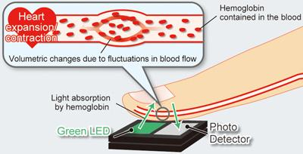
Fig. 1.1 Optical Heart Rate Sensor
Optical heart-rate monitors may measure heart rate precisely by analyzing the arterial pulse of underlying skin vascular beds and are either built into a wrist-worn gadget, an arm band, or a chest patch. Pulse waves, which modify a blood vessel's volume while the heart pumps blood, are measured using an optical heart rate sensor. An optical sensor and green LED are used to measure the volume change in order to identify pulse waves. It was discovered that heart rate sensors deliver precise readings regardless of the user's age. High sensitivity, tolerance to electromagnetic interference, small size, light weight, flexibility, and the ability to deliver multiplexed or distributed sensing are only a few of its special advantages.

- Accelerometer sensor
An instrument that monitors the acceleration of any person or object in its immediate rest frame is an accelerometer sensor. Acceleration, or the change in speed (velocity) per unit of time, is measured using accelerometer sensors, which are integrated circuits.
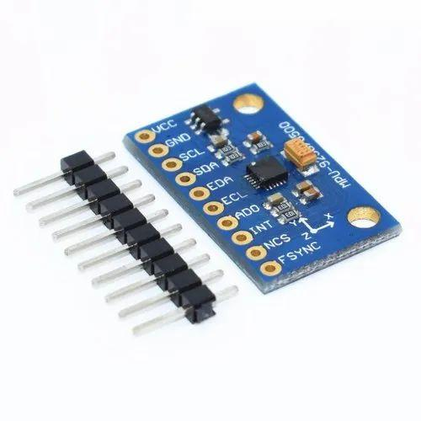
Fig. 1.2 Accelerometer Sensor
Numerous electronic products, smartphones, wearable technology, and other applications employ accelerometer sensors in various ways. Accelerometers are capable of measuring vibration on vehicles, equipment, structures, process control systems, and safety installations. Aside from seismic activity, they can also be used to gauge tilt, machine vibration, dynamic distance, and speed with or without the effect of gravity.
Most sleeping devices use accelerometer sensors. This sensor is used to evaluate a patient's level of sleep-related movement. Here, our goals are to create and assess a heuristic algorithm for detecting sleep from accelerometer raw data and to compare sleep parameters with sleep diary entries accessed in daily life by adults and older adults.

- Gyroscope
A gyroscope is a tool for determining or maintaining orientation and angular velocity. It typically comprises of a rotating wheel or rotor that is positioned on an axis and can freely rotate in any direction. The rotor resists changes in the axis of its spin because it retains its orientation in space. Gyroscopes are utilized in many different fields, such as robotics, navigation systems, aerospace engineering, and the stabilization of cameras and drones. They also offer motion detecting capabilities in commonplace items like smartphones and game controllers.
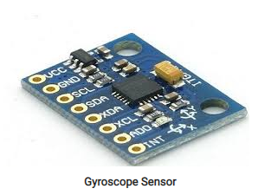
Fig. 1.3 Gyroscope
The gyroscope can detect minute changes in orientation brought on by breathing and heart rate during sleep, as well as more obvious movements like turning over or changing postures. The wearer's sleep length, sleep stages, and sleep quality can all be determined by examining these motions and changes over time using the smartwatch. The wearer's motions may be tracked by the gyroscope, which can also identify if they are in deep sleep, light sleep, or REM (rapid eye movement) sleep. Additionally, it has the ability to identify sleep disruptions including awakenings and snoring.

- Ambient Light Sensor
An ambient light sensor is a type of sensor commonly found in electronic devices such as smartphones, laptops, and smartwatches. It measures the amount of light in the environment and adjusts the device's display brightness accordingly. The ambient light sensor monitors the amount of light hitting a tiny photodiode or phototransistor in order to function. The sensor then sends a signal to the device's software, which adjusts the brightness of the display to a level appropriate for the ambient lighting conditions.
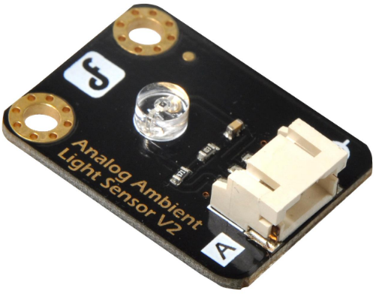
Fig. 1.4 Ambient Light Sensor
Ambient light sensors can also be used in sleep monitoring by detecting changes in the lighting conditions in a room. By measuring the amount of light in the environment, a sleep tracker or smartwatch can determine when the wearer has gone to bed and when they wake up. For example, when the wearer turns off the lights and goes to bed, the ambient light sensor can detect the drop in light levels and trigger the start of the sleep tracking. Similarly, when the wearer wakes up and turns on the lights, the sensor can detect the increase in light levels and trigger the end of the sleep tracking. In addition to tracking sleep duration, the ambient light sensor can also provide insights into the quality of sleep. For example, if the sensor detects changes in the light levels during the night, such as from a passing car or streetlight, it may indicate that the wearer had a restless night and was disturbed by external factors.
- Microcontroller
The microcontroller used in a smartwatch can vary depending on the specific brand and model of the watch. Some popular microcontrollers used in smartwatches include the ARM Cortex-M series and the STMicroelectronics STM32 series. For example, the Apple Watch Series 7 uses the Apple S7 SiP (System in Package), which includes a custom-designed Apple S7 processor based on the ARM Cortex-M architecture. Similarly, the Samsung Galaxy Watch 4 uses the Exynos W920, a processor developed by Samsung Electronics specifically for wearables, which is also based on the ARM Cortex-M architecture. Other smartwatches may use different microcontrollers depending on their specific requirements and design considerations. Ultimately, the choice of microcontroller will depend on factors such as performance requirements, power consumption, and cost.
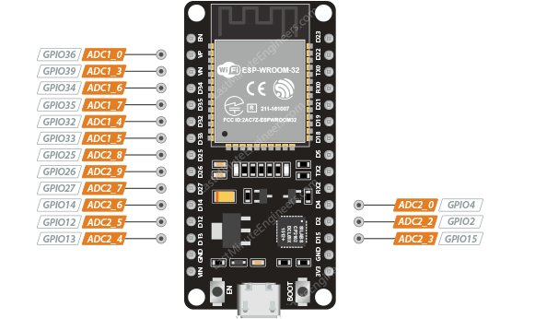
Fig.1.5 ESP 32 Microcontroller
The microcontroller plays an important role in smartwatches that monitor sleep, as it is responsible for collecting and processing data from the various sensors used to track sleep. The microcontroller typically receives data from the accelerometer, heart rate monitor, gyroscope, and ambient light sensor, and then uses algorithms to analyze this data and determine when the wearer is asleep and what stage of sleep, they are in. The microcontroller can also store this data and communicate it to the user or to a smartphone app. In addition to sleep monitoring, the microcontroller in a smartwatch can also perform other functions such as displaying the time and other notifications, tracking physical activity, and monitoring vital signs such as heart rate and blood oxygen levels.

Mobile Application
A tiny Android app that displays a patient's current sleep quality status has also been created. This app makes it easier to see the patient's sleep quality. It will be simple to determine the patient's general sleep condition thanks to calculated findings that the app may retrieve and display in a pie chart. Figure displays a screenshot of the application.
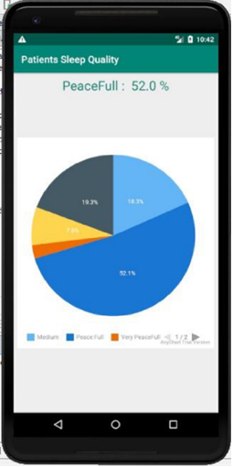
Fig 1.6 Mobile Application Screen Shot
Figure displays the patient's sleep data as a pie graph, which illustrates how the patient's sleep data is divided into five categories. According to the graph, the patient had restful sleep. In this graph, the sound sleep is depicted by the color blue.

Litrature survey
The sleeping disorder refers to when the user is unable to sleep their normal hours which build up stress and have subsequent drastic effects on user’s health. Some of the drastic effects of the sleeping disorders are depression and in major case the sleeping disorder sometimes led to unconditional heart which makes it quite vital and important for the user to have subsequent hours of sleep. In the busy and hectic world, it’s quite normal to get stressed but the nap in between the work enables better mind freshness and subsequently provides enhanced work focus. Several inventions have been developed which allows the user to get themselves relaxed at the workplace.
In the paper “Sleep monitoring systems: Current status and future challenges”, the authors draw attention to the shortcomings of current monitoring techniques like actigraphy and polysomnography in terms of accuracy and usefulness in daily life. [1] The lack of uniformity among various sleep monitoring technologies can make it challenging to compare the findings of different studies. When it comes to privacy and data security, there are ethical issues with the gathering and use of sleep data. In order to address the difficulties associated with sleep monitoring, the paper suggests some potential solutions, such as the creation of new monitoring technologies, the standardization of measurement procedures, increased cooperation between experts in various fields, and more study to determine the connection between sleep and health.
The article "A Real-Time Sleep Monitoring System with a Smartphone" describes a real-time sleep monitoring system that uses a smartphone's sensors and machine learning algorithms to track sleep patterns and stages. The system aims to address the shortcomings of existing sleep monitoring technology by providing a more workable and accessible solution. The study describes the challenges involved in developing a reliable and accurate sleep monitoring system, as well as the approach taken to overcome these challenges. The suggested approach was employed by a small test group of subjects, and the findings showed that it functioned brilliantly in identifying sleep stages and metrics linked to sleep quality. [2]
This research does a literature analysis on the application of the Internet of Things (IoT) for monitoring sleep quality in "Internet of Things for Sleep Quality Monitoring System: A Survey". The goal of the study is to outline the present trends, issues, and potential directions for further research in this area. The study discusses a range of subjects including sensor technology, data analytics, privacy and security concerns, and IoT-based sleep quality monitoring. The project intends to identify potential areas for IoT-based sleep monitoring research in the future and to provide insights into the challenges and potential of such systems. The authors proposed combining many sensors with data analytics techniques to improve the precision and. [3]
The primary goal of the study, described in the publication "Development of a sleep monitoring system with wearable vital sensor for home use," is to develop a wearable home sleep monitoring system. The study's main concern is the absence of an affordable, dependable sleep monitoring equipment that can be used at home to improve sleep quality and spot sleep disorders. To assess sleep quality and identify sleep disorders, the proposed system analyses the data. It achieves this by measuring vital signals including heart rate, breathing rate, and bodily movement with a wearable sensor. The study also examines and offers remedies for the difficulties in developing a wearable sleep monitoring system.[4]
An air-mattress with a balancing tube method is used in the study "Nonconstrained Sleep Monitoring System and Algorithms Using Air-Mattress with Balancing Tube Method" to provide a non-invasive method of monitoring sleep patterns. The system collects and processes data on different factors, including heart rate, respiration rate, body movements, and sleep stages, using non-invasive sensors and sophisticated algorithms. The system is a dependable and efficient instrument for sleep monitoring since it offers insightful information about the quality of sleep and potential sleep problems. In comparison to polysomnography (PSG), which is regarded as the gold standard for sleep monitoring, the study undertaken to assess the accuracy of the system demonstrates high accuracy in recognizing sleep stages.[5]
The study "Development and Preliminary Validation of Heart Rate and Breathing Rate Detection Using a Passive, Ballistocardiography-Based Sleep Monitoring System" describes the development of a passive, ballistocardiography-based sleep monitoring system that can track heart rate and breathing rate while a person sleeps. A pressure-sensitive pad positioned beneath the mattress is used by the system to find ballistocardiographic (BCG) signals, which are produced by the body's movements while you sleep. Advanced algorithms are used to process the BCG signals in order to detect heart rate and breathing rate, which provides important data on the user's sleep patterns. The system is a reliable and efficient tool for sleep monitoring because the study used to confirm its accuracy reveals that it has a high accuracy in detecting heart rate and breathing rate when compared to polysomnography (PSG).[7]
A long-term sleep monitoring system that can measure sleep parameters using an unconstrained technique is presented in the publication "Long-term Sleep Monitoring System and Long-term Sleep Parameters using Unconstrained Method" by Jeyhun Shin, Young Joon Chee, and Kiangsu Park. It demonstrates a long-term sleep monitoring system that measures several aspects of sleep using an unrestricted technique. The system utilizes a bed-based sensor system that can detect body movements, respiratory signals, and heart rate to calculate sleep stages, sleep efficiency, and other sleep parameters. The study shows that the system can accurately measure sleep parameters over long periods of time, making it a valuable tool for monitoring sleep disorders and evaluating the effectiveness of treatments. Overall, the system provides valuable insights into sleep patterns and potential sleep disorders while maintaining user comfort and ease of use.[8]
A study comparing the accuracy of sleep-tracking technology with polysomnography in teenagers is presented in the article "Validation of Sleep-Tracking Technology Compared with Polysomnography in Adolescents" by Massimiliano de Zambotti, Fiona C. Baker, and Ian M. Colrain. In this study, the accuracy of the widely used Fitbit Charge HR sleep tracker was compared to that of teenage polysomnography. The 25 individuals in the study discovered that, when compared to polysomnography, the Fitbit significantly overestimated total sleep time, sleep start latency, and waking after sleep onset. The study emphasizes the value of exercising caution when utilizing sleep-tracking technology for clinical or research reasons and contends that additional study is required to increase the devices' accuracy. In conclusion, the article offers insightful information about the limitations of sleep tracking technologies and [9]
Zilu Liang and Bernd Plunderer’s paper "Sleep tracking in the real world: a qualitative study into barriers for improving sleep" gives a qualitative study on the challenges associated with using sleep-tracking technology to improve sleep. The article offers a qualitative investigation of the challenges to using sleep-tracking technologies to improve sleep. The study involved 12 participants who used a sleep-tracking device, and the results showed that accuracy and reliability of the device were significant concerns for the participants. Additionally, participants reported that the sleep data provided by the devices did not necessarily lead to changes in behavior or better sleep quality. The paper highlights the importance of considering user experience and motivation when designing sleep-tracking technology and the need for further research to improve the usability and effectiveness of such devices. [10]
The paper "Pajama’s, Polysomnography and Professional Athletes: The Role of Sleep Tracking Technology in Sport" by Driller et al. discusses the use of sleep tracking technology in professional athletes. The paper presents a case study of a professional rugby team that used sleep tracking devices to monitor their sleep and optimize their recovery. The study found that sleep tracking technology can provide valuable information for athletes and coaches to identify and address sleep-related issues, which can improve performance and reduce the risk of injury. The paper also highlights the challenges of using sleep tracking technology in a sports context, such as the need for reliable and accurate data and the importance of privacy and data protection. Overall, the paper provides insights into the potential benefits and challenges of using sleep tracking technology in professional sports. [11]
The study "How Does Sleep Tracking Influence Your Life?" by Koosharem et al. explores how people's behavior and perceptions of sleep are affected by sleep monitoring technologies. Twenty people participated in the study, each of whom utilized a sleep tracking device and answered questionnaires and interviews. The findings demonstrated that the use of sleep tracking equipment improved participants' awareness of and comprehension of their sleep patterns, resulting in modifications to sleep behavior and routines. However, the study also revealed concerns around data privacy, accuracy of the devices, and the potential for sleep tracking technology to create stress and anxiety around sleep. Overall, the paper highlights the potential benefits and drawbacks of sleep tracking technology, emphasizing the need for further research and design improvements to maximize the positive impact of such devices. [12]
A non-invasive sleep monitoring system that uses body movement signals to track sleep patterns is proposed in the paper "The Design and Realization of Sleep-monitoring System Based on Body-movement Signals" by Wei et al. The technology collects and analyses data on body movement while you sleep using an accelerometer and a microcontroller. To analyze movement data and categorize sleep stages, the authors suggest a sleep stage classification algorithm based on the Fast Fourier Transform (FFT) and linear discriminant analysis (LDA) methods. Five healthy individuals were used to test the system, and the findings indicated that it could classify sleep stages with some accuracy. The suggested system offers a low-cost and non-invasive replacement for conventional sleep monitoring methods, which may be helpful for applications involving home-based sleep monitoring. [13]
A high-performance and resource-efficient sleep monitoring system built on the Internet of Things (IoT) is presented in the paper "High-Performance and Resource-Efficient IoT-based Sleep Monitoring System". The device collects body movement information and snoring sounds using an accelerometer and a microphone, respectively, and sends the information to a cloud server for analysis. The suggested method is built to ensure precise sleep tracking while minimizing power usage and data transmission. The experimental results show the system's efficiency in accurately identifying sleep stages and sleep-related events, pointing to its potential for use in real-world sleep monitoring and management. [14]
The article "An unobtrusive sleep monitoring system for the human sleep behaviour understanding" describes an unobtrusive sleep monitoring system based on a bed sensor for recording sleep-related body movements and a smartphone application for gathering self-reported sleep data. The proposed system seeks to identify sleep problems and to give an accurate and comprehensive picture of sleep behaviour, including sleep onset, duration, efficiency, and quality. Pilot research using 10 healthy people to test the system revealed that it can give useful data for sleep monitoring and management and has the potential to be utilized for the diagnosis and treatment of sleep disorders. [15]
An inconspicuous sleep monitoring system based on a bed sensor for collecting sleep-related body movements and a smartphone application for gathering self-reported sleep data is described in the paper "An unobtrusive sleep monitoring system for the understanding of human sleep behaviour." The suggested method aims to pinpoint sleep issues and provide a precise and thorough analysis of sleep behaviour, including sleep onset, duration, effectiveness, and quality. The system can provide relevant data for sleep monitoring and management, and it has the potential to be used for the diagnosis and treatment of sleep problems, according to a pilot study utilizing 10 healthy persons to test the system. [16]
A literature review is published in "A survey on sleep assessment methods" by Vanessa Ibanez, Joseph Silva, and Omar Cauli with the goal of summarizing and contrasting the most recent sleep evaluation techniques. They discovered that, in terms of accuracy, sleep detection techniques can be categorized as follows after analyzing all of the current sleep evaluation techniques:
Questionnaire Contactless devices, contact devices, contact devices, and polysomnography

According to a survey of the literature, current subjective approaches have a sensitivity range of 73% to 97.7% and a specificity range of 50% to 96%. A sensibility of greater than 90% is presented by objective techniques like actigraphy. One drawback of such technology is that their specificity is low in comparison to their sensitivity. [17]
Different treatments for sleeping difficulties are suggested in "Assistive technology to enable sleep function in patients with acquired brain injury: Issues and opportunities" by Anmol Biajar, Tatyana Mollayeva, Sandra Sokoloff, and Angela Colantonio. They suggested treatments such as nasotracheal suction mechanical ventilation, adaptive servo-ventilation, light therapy, positional therapy, cognitive behavioral therapy, and continuous positive airway pressure (CPAP) therapy. These are some basic treatments for people with brain injuries who have sleeping problems. [18]
The authors of "Non-invasive analysis of sleep patterns via multimodal sensor input" are Vangelis Metis, Dimitris Kotsiopoulos, Vassilis Athetoses, and Fillia Mak. They use Microsoft Kinect and a bed pressure mat sensor to examine people's sleep habits. They gathered information from seven different people by imitating their sleeping patterns. Each person spent some time lying on their bed and carried out the activities they would usually do before going to sleep. Two distinct sensors were used to record the various actions taken during that time. then placed a bed pressure mat underneath the covers for the first one, and then affixed a Microsoft Kinect sensor to the ceiling for the second. The captured information was then manually annotated in accordance with. [19]
By using polysomnography (PSG) as the gold standard, Xuan Kai Lee et al.'s paper "Validation of a Consumer Sleep Wearable Device with Actigraphy and Polysomnography in Adolescents Across Sleep Opportunity Manipulations" sought to validate a consumer sleep wearable device for monitoring sleep stages and parameters in adolescents. The study discovered that while the consumer device was less accurate for detecting sleep stages, it was accurate for assessing total sleep time, sleep start latency, and wake after sleep onset. The device is a helpful tool for tracking adolescent sleep, but the authors warn against using only its readings for clinical diagnoses. [20]
The paper "Validation of a Consumer Sleep Wearable Device with Actigraphy and Polysomnography in Adolescents Across Sleep Opportunity Manipulations" by Xuan Kai Lee et al. sought to validate a consumer sleep wearable device for monitoring sleep stages and parameters in adolescents using polysomnography (PSG) as the gold standard. The research found that while the consumer device had lower sensitivity for identifying different stages of sleep, it was precise for measuring total sleep time, sleep start latency, and wakefulness following sleep onset. Although the gadget is useful for monitoring adolescent sleep, the scientists advise against using its findings alone to make clinical diagnosis. [21]
A system, method, and item for stress reduction and sleep promotion are disclosed in U.S. Pat. No. 11013883B2, which was created by Todd Youngblood and Tara Youngblood of Mooresville, North Carolina (US). A system for reducing stress and promoting sleep includes at least one remote control and a piece of equipment for regulating surface temperature. In some implementations, the system for promoting sleep and reducing stress includes at least one body sensor, at least one remote server, and/or a pulsed electromagnetic frequency device. [22]

A bed with a mattress and a foot warming system is described in U.S. Patent No. 20210289947A1 by inventors Ronald Stuarant BENSON of Toronto, California, and Ryan Cameron DENOMME of Kitchener, California. A support structure that is positioned beneath and covered by the mattress cover may also be included in the mattress. A heating unit, an envelope, a power source, and an electrical connector that connects the heating unit to the power source are all possible components of the foot warming system. Between the top and bottom of the enclosure, the heating unit may be positioned inside. At the foot of the bed, between the support framework and the mattress cover, the heating unit and the envelope. [23]

related work
We may divide current research on modern sleep monitoring systems into four areas.
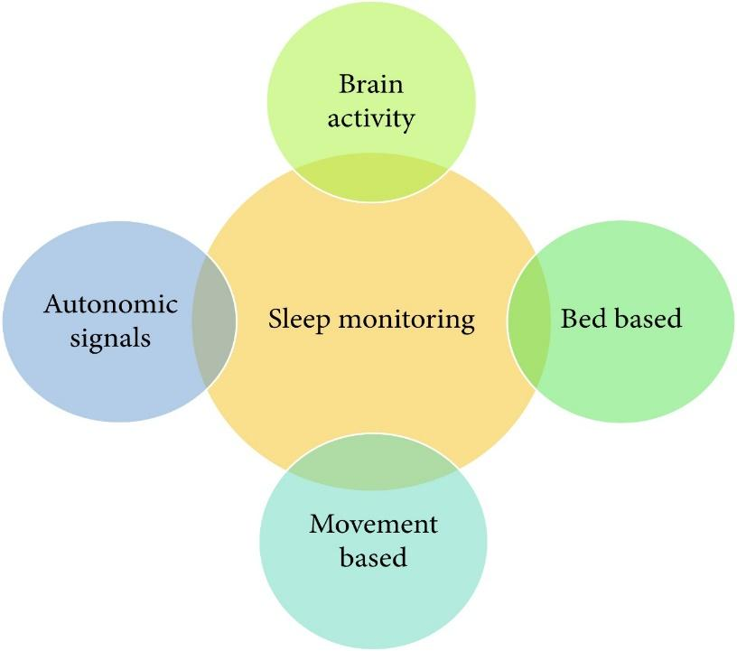
Fig. 2.1 Related work Category

Different sensor methods are used by contemporary sleep monitoring devices. The staging of sleep can also be done using these sensors. The suggested system does not address various stages of sleep. A type of sleep monitoring technique called polysomnography (PSG) examines physiological parameters like breathing, body temperature, muscle movement, and oxygen saturation (SPO2). Researchers can categorize the time of sleep onset and wake-up using this technology. To monitor the patient's bodily parameters or changes as he slept, a gadget was fastened to his wrist. Investigation shows a clear connection between wrist movement and the user's sleep level. The patient's sleep status can also be determined using audio-video recording and a passive infrared (PIR) sensor in a different way.
An ambient sleep monitoring technique using in-home sensors is demonstrated in the current study. PIR sensors for motion detection, interaction sensors that are attached to windows and doors, room temperature monitors, and other devices that can detect heat and energy are all included in this study.

existing system
As stated in Table, a number of other devices are also available and are currently utilized for sleep evaluation at home. Many of these are available for purchase in the market. The comparison of several REM (rapid eye movement) and NREM (nonrapid eye movement) sleep monitoring equipment is shown in the table below.
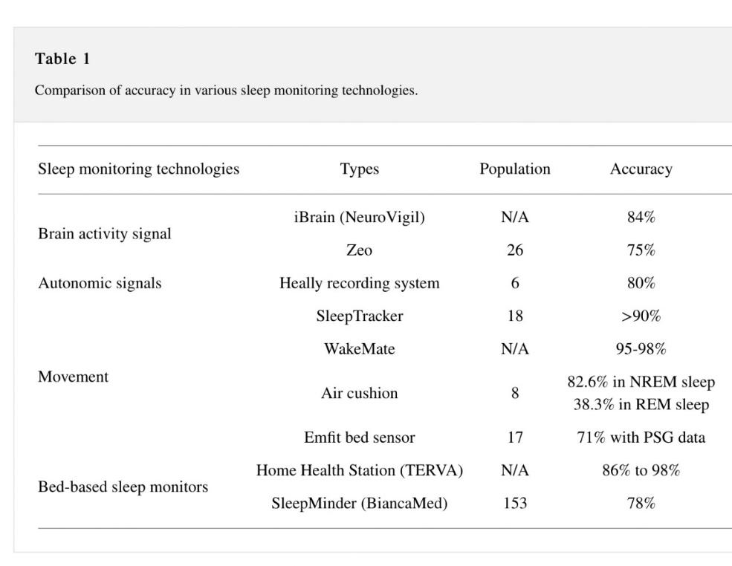
The headgear, which records sole front lead EEG impulses, is part of the iBrain. The Zeo device measures electroencephalogram (EEG), electromyography muscle electromyogram (EMG), and electrooculogram (EOG) signals and transmits the data to a mobile phone via Wi-Fi or Bluetooth using a headband made of plastic and cloth that is worn on the forehead. The Heally system uses sensors that are integrated into a shirt to estimate the patient's respiratory and cardiac motions. Another gadget that is attached to a watch is the SleepTracker. This wristwatch records sleep-related human activity. The WakeMate system comprises of a bracelet that the patient wears around their wrist. A mobile phone receives actigraphy data from this band. This data includes the amount of time spent sleeping overall, the frequency with which the patient is awake while sleeping, and data on the "sleep quality" based on physical activity. An air cushion is a beanbag that has air inside of it and can compute various environmental and physical factors. Emfit Bed Sensor uses Emfit foil electrodes that are placed beneath a mattress to determine factors such as breathing rate, heart rate, and body movement.
Modern society frequently uses mobile devices, which also offer a number of apps to track patients' sleep. Heart rate signals, acoustic signals, and accelerometer data are all used in a system known as ubiquitous architecture for sleep monitoring. This concept functions in conjunction with a smartwatch or smartphone-based monitoring system. Additionally, it proposes an original and clever signal organization algorithm.
The aforementioned techniques and technologies are useful for examining patients' sleep, despite this. There are a lot of disadvantages as well. The majority of them lack a foundation in machine learning and the IoT. The Internet of Things (IoT) concept, which is now popular and developing, comprises of numerous sensing devices, data transfer protocols, and cloud computing capabilities. Such models can only be practical for a short period of time because data processing on devices like mobile devices uses a lot of energy.

Problem of existing system
The existing systems are more focused on providing the assistance to the user in monitoring the sleep and guiding the user to get relaxed while sleeping using various attachments. The inventions are not focused monitors the real time health related parameters of the user while they take nap and does not provide the user with favorable ambient conditions and no means to determine their real time location at the time of nap.
In order to overcome the aforementioned drawbacks, here the proposed device will allow the user to take a nap from busy schedules and prevent the user from getting stressed and monitors the real time health related parameters of the user while they take nap along with locating the user while they are having the nap. It will also recommend the time to take nap based on the busy schedule of a person. It will monitor the sleeping activity and duration of a person and help them to provide information about their sleep activity and will also advise them how they can improve it.

proposed system
For overcoming all the limitations of existing system, we are going to propose a personalized sleep analysis algorithm that will not only monitor the sleep activities, but it will also provide feedback, measures and diet suggestion for effective sleep.
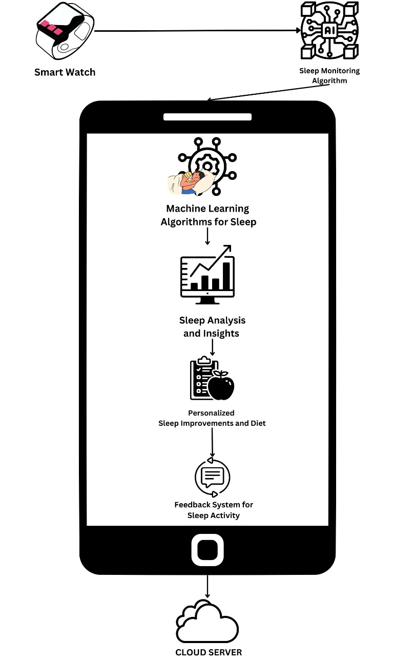
Fig. 3.1 Proposed System
- Smartwatch: This component is responsible for collecting data about the user's sleep, such as sleep duration, sleep quality, and REM sleep. The sensor will be embedded in the smartwatch and will collect data throughout the night.
- Sleep Monitoring Algorithm: This component will collect and process the data collected by the smartwatch sensor, generate a sleep score, and initiate the machine learning algorithms for sleep analysis.
- Machine Learning Algorithms: This component will analyze the sleep score generated by the sleep monitoring algorithm and provide insights and recommendations for sleep improvement.
- Sleep Analysis and Insights: This component will analyze the data collected by the smartwatch sensor and provide insights into the user's sleep patterns, such as when they are most likely to wake up, how often they wake up during the night, and how much deep and REM sleep they are getting.
- Personalized Sleep Improvements and Diet: This component will provide personalized recommendations for improving the user's sleep, as well as recommendations for their diet based on their sleep data. This component will take into account the user's sleep patterns, sleep score, and diet preferences to provide tailored recommendations.
- Feedback System for Sleep Activity: This component will provide feedback on the user's sleep activity, such as whether they are meeting their sleep goals, and suggestions for how they can improve their sleep habits. This component will also provide feedback on their diet, such as whether they are eating a balanced diet that supports good sleep.
- Sleep Data Storage: This component will store the user's sleep data in a secure and reliable database for future analysis and reference

system architecture
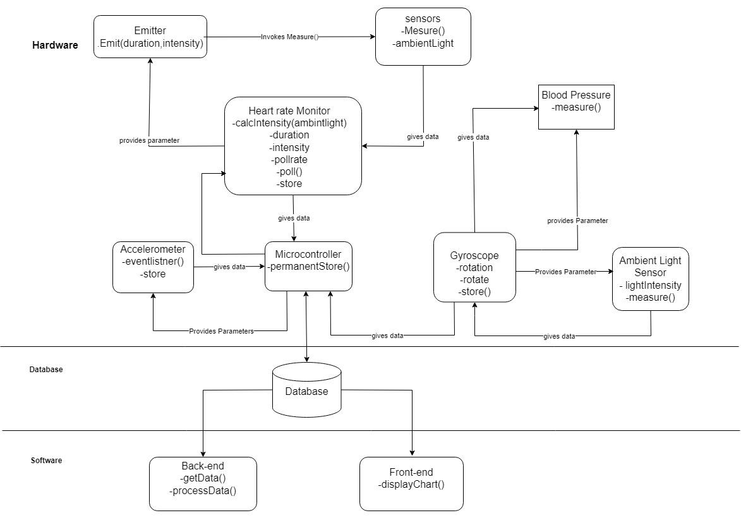
Fig. 3.1 System Architecture
Set of programs plus data plus documentation along with mechanisms, methods and procedures. A system is a set of components that combine together to achieve common goal. It can be comprised of hardware and software. This system design is divided into hardware, database and software.

Hardware

- Microcontroller
Microcontroller is used for collecting and processing data from the various sensors used to track sleep. It receives data from all the other hardware components, processes them and instructs the other component. It is also responsible for sending data to the database.

- Optical Heart rate monitor
It is responsible for measuring the heart rate and storing it. It is divided into two components, and they are:
- emitter
- sensor
The emitter is responsible for producing light so that the sensor can take the reading. The sensor is responsible for measuring the heart rate as well as the available ambient light. The ambient light data is sent to the Microcontroller to calculate the required duration and intensity of light so that the sensor can take the reading.

- Accelerometer
It is responsible for detecting any movement of the user during sleep. The measured movement is then sent to the Microcontroller. The sensitivity is adjusted by the Microcontroller.

- Gyroscope
Gyroscopes are able to recognize small variations in orientation brought on by breathing and heart rate as well as more obvious movements like turning over or changing postures. The wristwatch can provide information on the wearer's sleep length, sleep stages, and sleep quality by examining these motions and changes over time.

- Ambient Light Sensor
Ambient light sensors can also be used in sleep monitoring by detecting changes in the lighting conditions in a room. By measuring the amount of light in the environment, a sleep tracker or smartwatch can determine when the wearer has gone to bed and when they wake up.

Database:
- A microcontroller contacts a web server through HTTP.
- PHP script is run by the web server.
- PHP script interacts with MySQL database after processing data from HTTP Request.
- After processing the outcome, the PHP script sends an HTTP response with the outcome to Microcontroller.
Software:
In terms of software, it makes use of a mobile application with a machine learning algorithm that can recommend ways to enhance sleep.
The first stage would be to compile information on the user's sleeping habits, which can be done with the help of a smartwatch or other wearable gadget that can track sleep. This information may consist of parameters like total amount of sleep, duration of each sleep stage, sleep disruptions, and heart rate variability.
Following the collection of the data, a machine learning model can be trained to examine the patterns and make recommendations for enhancing sleep. Regression analysis, decision trees, or neural networks are just a few of the methods the model may employ to find connections between the data and particular elements that might have an impact on how well you sleep.
The model could then propose actions the user can take to improve their sleep based on these relationships. For instance, the model might advise the user to cut back on their caffeine intake before bed if it finds a link between poor sleep quality and high caffeine intake. Similar to this, if the model notices that the user frequently wakes up in the middle of the night, it can advise them to adopt a regular bedtime routine or work on calming techniques before bed.

Conclusion
In conclusion, a sleep monitoring system that uses a smartwatch and machine learning algorithms can provide users with valuable insights into their sleep patterns and recommendations for improving their sleep quality. By collecting data on sleep duration, sleep quality, and other sleep-related metrics, the system can provide personalized insights into sleep patterns, such as when the user is most likely to wake up and how often they wake up during the night. Machine learning algorithms can then analyze this data and provide tailored recommendations for improving sleep, such as adjusting sleep schedules or changing sleeping positions. Additionally, by including a feedback system that provides suggestions on sleep activity and diet, the system can provide users with a comprehensive set of recommendations for improving their overall health and well-being. A sleep monitoring system that uses a smartwatch and machine learning algorithms has the potential to be a powerful tool for individuals looking to improve their sleep quality and overall health. With the right design and implementation, such a system can provide users with valuable insights and personalized recommendations, ultimately leading to better sleep and a better quality of life.

References
- Ibáñez V, Silva J, Cauli O. A survey on sleep assessment methods. PeerJ. 2018 May 25;6:e4849. doi: 10.7717/peerj.4849. PMID: 29844990; PMCID: PMC5971842.
- Biajar, Anmol, Tatyana Mollayeva, Sandra Sokoloff, and Angela Colantonio. “Assistive Technology to Enable Sleep Function in Patients with Acquired Brain Injury: Issues and Opportunities.” British Journal of Occupational Therapy 80, no. 4 (April 2017): 225–49. https://doi.org/10.1177/0308022616688017.
- Metsis, V., Kosmopoulos, D., Athitsos, V. et al. Non-invasive analysis of sleep patterns via multimodal sensor input. Pers Ubiquit Comput 18, 19–26 (2014). https://doi.org/10.1007/s00779-012-0623-1
- Lee XK, Chee NIYN, Ong JL, Teo TB, van Rijn E, Lo JC, Chee MWL. Validation of a Consumer Sleep Wearable Device With Actigraphy and Polysomnography in Adolescents Across Sleep Opportunity Manipulations. J Clin Sleep Med. 2019 Sep 15;15(9):1337-1346. doi: 10.5664/jcsm.7932. PMID: 31538605; PMCID: PMC6760396.
- Ronald Stuart BENSON, Ryan Cameron DENOMME. Sleep monitoring system (2018) U.S. Pat. No.10874350B2
- Todd Youngblood, Tara Youngblood Stress reduction and sleep promotion system (2021) U.S. Pat No.11013883B2
- Kody Lee Karschnik, Omid Sayadi, Wade Daniel Palashewski, Ramazan Demirli, Eric Rose, Saurabh Chhaparwal Bed with foot warming system (2020) U.S. Pat No. 20210289947A1.
- PAN, Qiang & Brulin, Damien & Campo, Eric. (2020). Sleep monitoring systems: Current status and future challenges (Preprint). JMIR Biomedical Engineering. 5. 10.2196/20921.
- T. -Y. Han, S. -D. Min and Y. Nam, "A Real-Time Sleep Monitoring System with a Smartphone," 2015 9th International Conference on Innovative Mobile and Internet Services in Ubiquitous Computing, Santa Catarina, Brazil, 2015, pp. 458-461, doi: 10.1109/IMIS.2015.69.
- N. Surantha, G. P. Kusuma and S. M. Isa, "Internet of things for sleep quality monitoring system: A survey," 2016 11th International Conference on Knowledge, Information and Creativity Support Systems (KICSS), Yogyakarta, Indonesia, 2016, pp. 1-6, doi: 10.1109/KICSS.2016.7951426.
- Suzuki, Takuji & Ouchi, Kazushige & Kameyama, Ken-Ichi & Takahashi, Masaya. (2009). Development of a Sleep Monitoring System with Wearable Vital Sensor for Home Use.. 326-331.
- Nonconstrained Sleep Monitoring System and Algorithms Using Air-Mattress With Balancing Tube Method. (2010, January 1). IEEE Journals & Magazine | IEEE Xplore. https://ieeexplore.ieee.org/stamp/stamp.jsp?tp=&arnumber=5290162&tag=1
- Development and Preliminary Validation of Heart Rate and Breathing Rate Detection Using a Passive, Ballistocardiography-Based Sleep Monitoring System David C. Mack, James T. Patrie, Paul M. Suratt, Robin A. Felder, and Majd Alwan, Senior Member, IEEE https://ieeexplore.ieee.org/stamp/stamp.jsp?tp=&arnumber=4663856
- Promises and Challenges in the Use of Consumer-Grade Devices for Sleep Monitoring Sirinthip Roomkham , David Lovell , Joseph Cheung , and Dimitri Perrin. https://ieeexplore.ieee.org/stamp/stamp.jsp?tp=&arnumber=8309286
- Long-term Sleep Monitoring System and Long-term Sleep Parameters using Unconstrained Method Jaehyuk Shin, Youngjoon Chee, and Kwangsuk Park, Member, IEEE https://citeseerx.ist.psu.edu/document?repid=rep1&type=pdf&doi=7bb91d3bbf05f30ba1dcaa7d4ebf9ffb0c7042f9
- de Zambotti M, Baker FC, Colrain IM. Validation of Sleep-Tracking Technology Compared with Polysomnography in Adolescents. Sleep. 2015 Sep 1;38(9):1461-8. doi: 10.5665/sleep.4990. PMID: 26158896; PMCID: PMC4531414.
- Zilu Liang and Bernd Ploderer. 2016. Sleep tracking in the real world: a qualitative study into barriers for improving sleep. In Proceedings of the 28th Australian Conference on Computer-Human Interaction (OzCHI '16). Association for Computing Machinery, New York, NY, USA, 537–541. https://doi.org/10.1145/3010915.3010988
- Driller, M. W., Dunican, I. C., Omond, S. E. T., Boukhris, O., Stevenson, S., Lambing, K., & Bender, A. (2023). Pyjamas, Polysomnography and Professional Athletes: The Role of Sleep Tracking Technology in Sport. Sports, 11(1), 14. https://doi.org/10.3390/sports11010014
- Kuosmanen, E., Visuri, A., Kheirinejad, S., Van Berkel, N., Koskimäki, H., Ferreira, D., & Hosio, S. (2022). How Does Sleep Tracking Influence Your Life? Proceedings of the ACM on Human-computer Interaction, 6(MHCI), 1–19. https://doi.org/10.1145/3546720
- Y. Wei et al., "The Design and Realization of Sleep-monitoring System Based on Body-movement Signals," 2019 2nd International Conference on Safety Produce Informatization (IICSPI), Chongqing, China, 2019, pp. 533-536, doi: 10.1109/IICSPI48186.2019.9096055.
- N. Surantha, O. K. Utomo and S. M. Isa, "High-Performance and Resource-Efficient IoT-based Sleep Monitoring System," 2020 IEEE 91st Vehicular Technology Conference (VTC2020-Spring), Antwerp, Belgium, 2020, pp. 1-5, doi: 10.1109/VTC2020-Spring48590.2020.9129521.
- P. Barsocchi, M. Bianchini, A. Crivello, D. La Rosa, F. Palumbo and F. Scarselli, "An unobtrusive sleep monitoring system for the human sleep behaviour understanding," 2016 7th IEEE International Conference on Cognitive Infocommunications (CogInfoCom), Wroclaw, Poland, 2016, pp. 000091-000096, doi: 10.1109/CogInfoCom.2016.7804531.
- S. T. -B. Hamida and B. Ahmed, "A remote deep sleep monitoring system based on a single channel for in-home insomnia diagnosis," 2015 7th International Conference on New Technologies, Mobility and Security (NTMS), Paris, France, 2015, pp. 1-2, doi: 10.1109/NTMS.2015.7266469.

